Supplementary information for: TAPHONOMY AND PALEOECOLOGY OF AN OPHIUROID-STYLOPHORAN OBRUTION DEPOSIT FROM THE LOWER DEVONIAN BOKKEVELD GROUP, SOUTH AFRICA

This file contains supplementary figures and tables referred to throughout the text.
SUPPLEMENTARY FIGURE 1. — Placocystella africana (Reed, 1925), Lower Devonian Voorstehoek Formation, Western Cape, South Africa. (A) Specimen SAM-PB-022508A Disarticulated upper thecal surface showing typical “cigar-like” posterior spines. (B) Counterpart SAM-PB-022508B, showing proximal aulacophore. Photographs taken from silicone moulds there were whitened with ammonium chloride. (C)-(D) CT scan images of the same specimen. Abbreviations: dig. = digital; gloss. = glossal.

SUPPLEMENTARY FIGURE 2. — (A) Paranacystis cf. petrii Caster, 1954 from the Lower Devonian Voorstehoek Formation, Western Cape, South Africa specimen SAM-PB-022509 (B) A series of CT images of various specimens found throughout the Karbonaatjies obrution bed. Abbreviations: l.m = lateral marginals; d.a = distal aulacophore; p.a = proximal aulacophore.

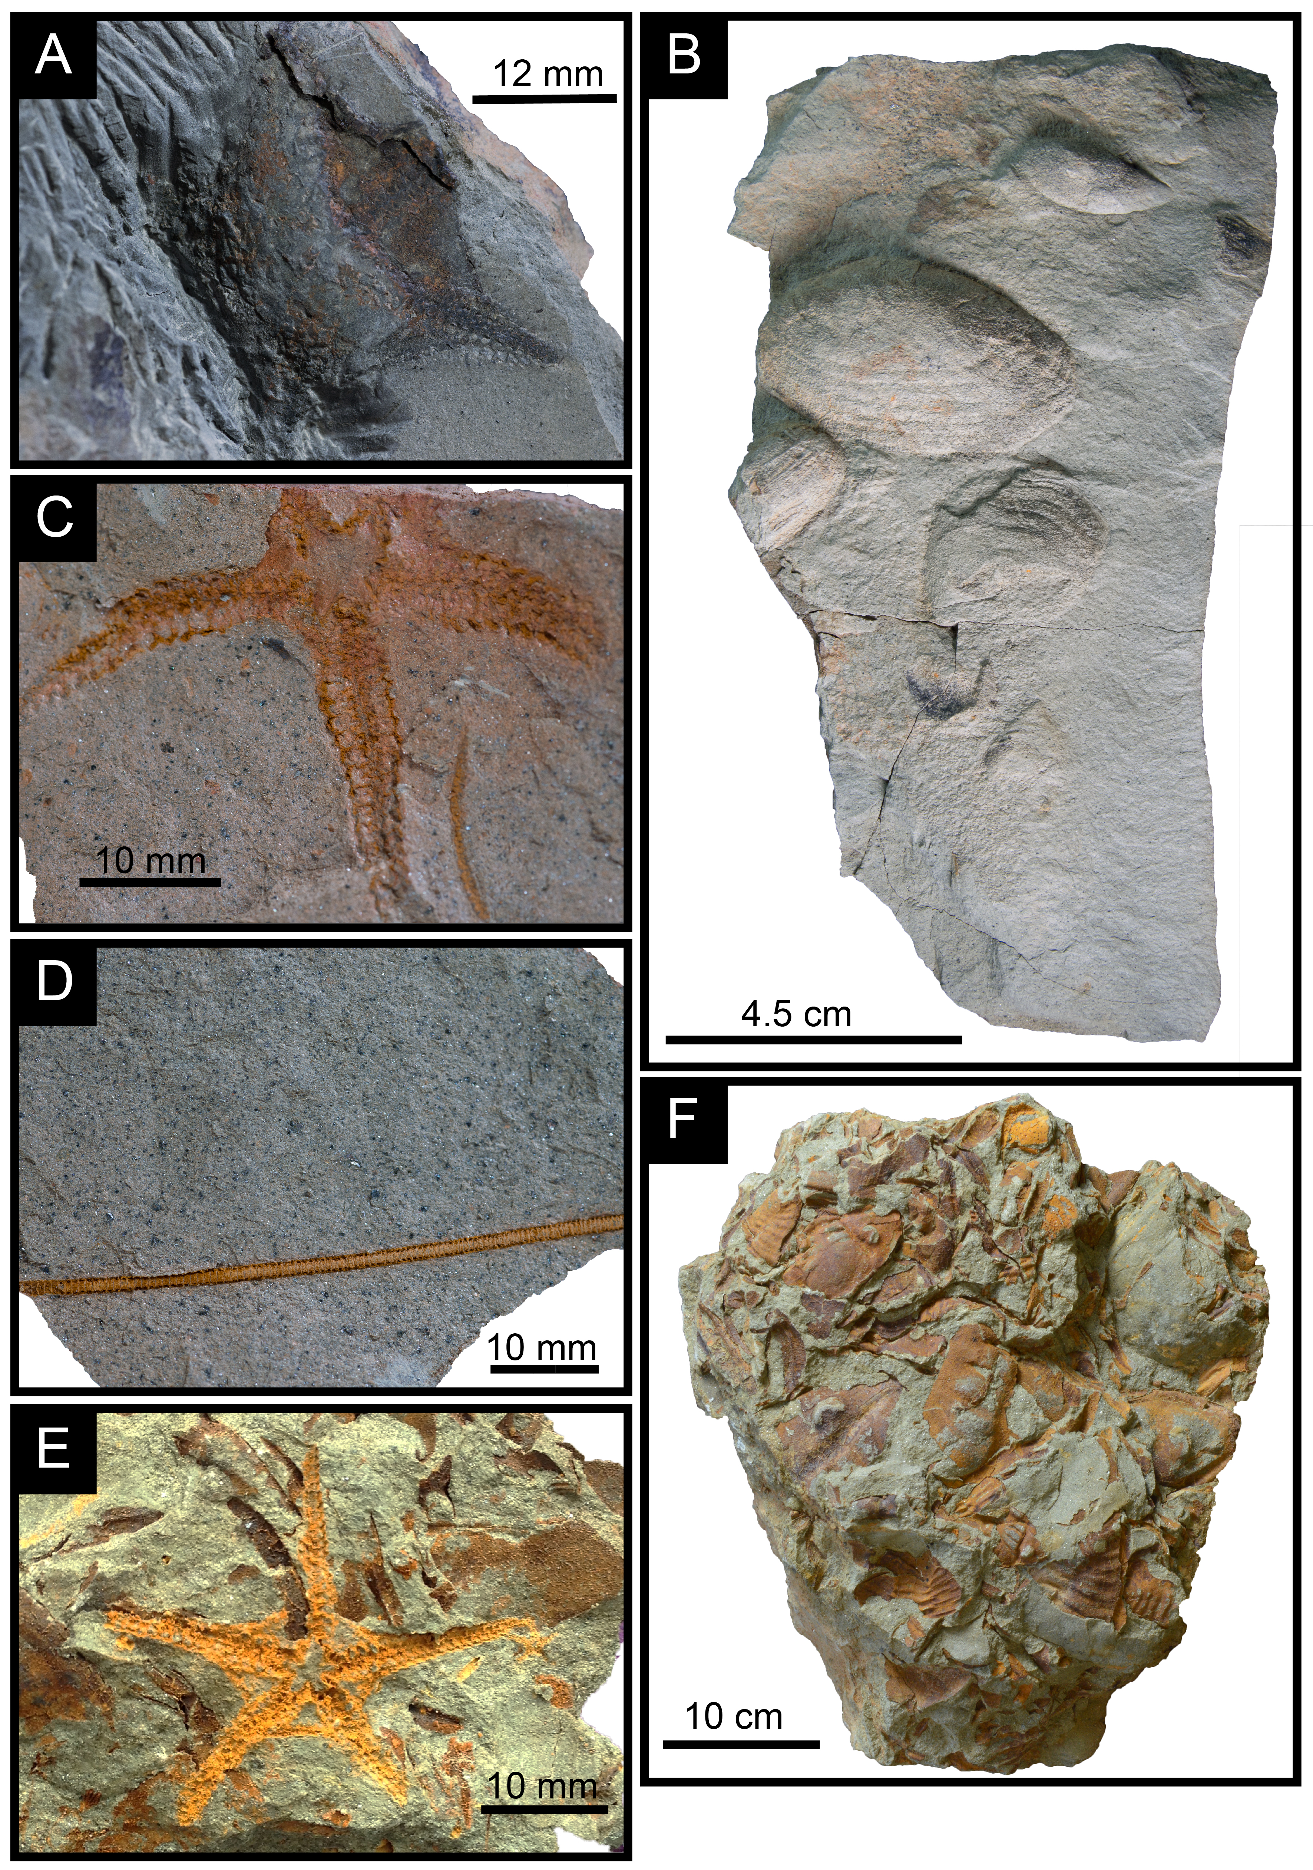
SUPPLEMENTARY FIGURE 3. — Associated Fossiliferous Beds (A) One partially complete Eophiura sp. (SAM-PB-022505A), (B) Convex up left valves of ?Palaeoneilo and a single Nuclulites sp. (C) Unidentified ophiuroid preserved with a single crinoid stem (D), and (E) Haughtonaster reedi (SAM-PB-022507) preserved within a trilobite moult assemblage of Bainella africana (F).

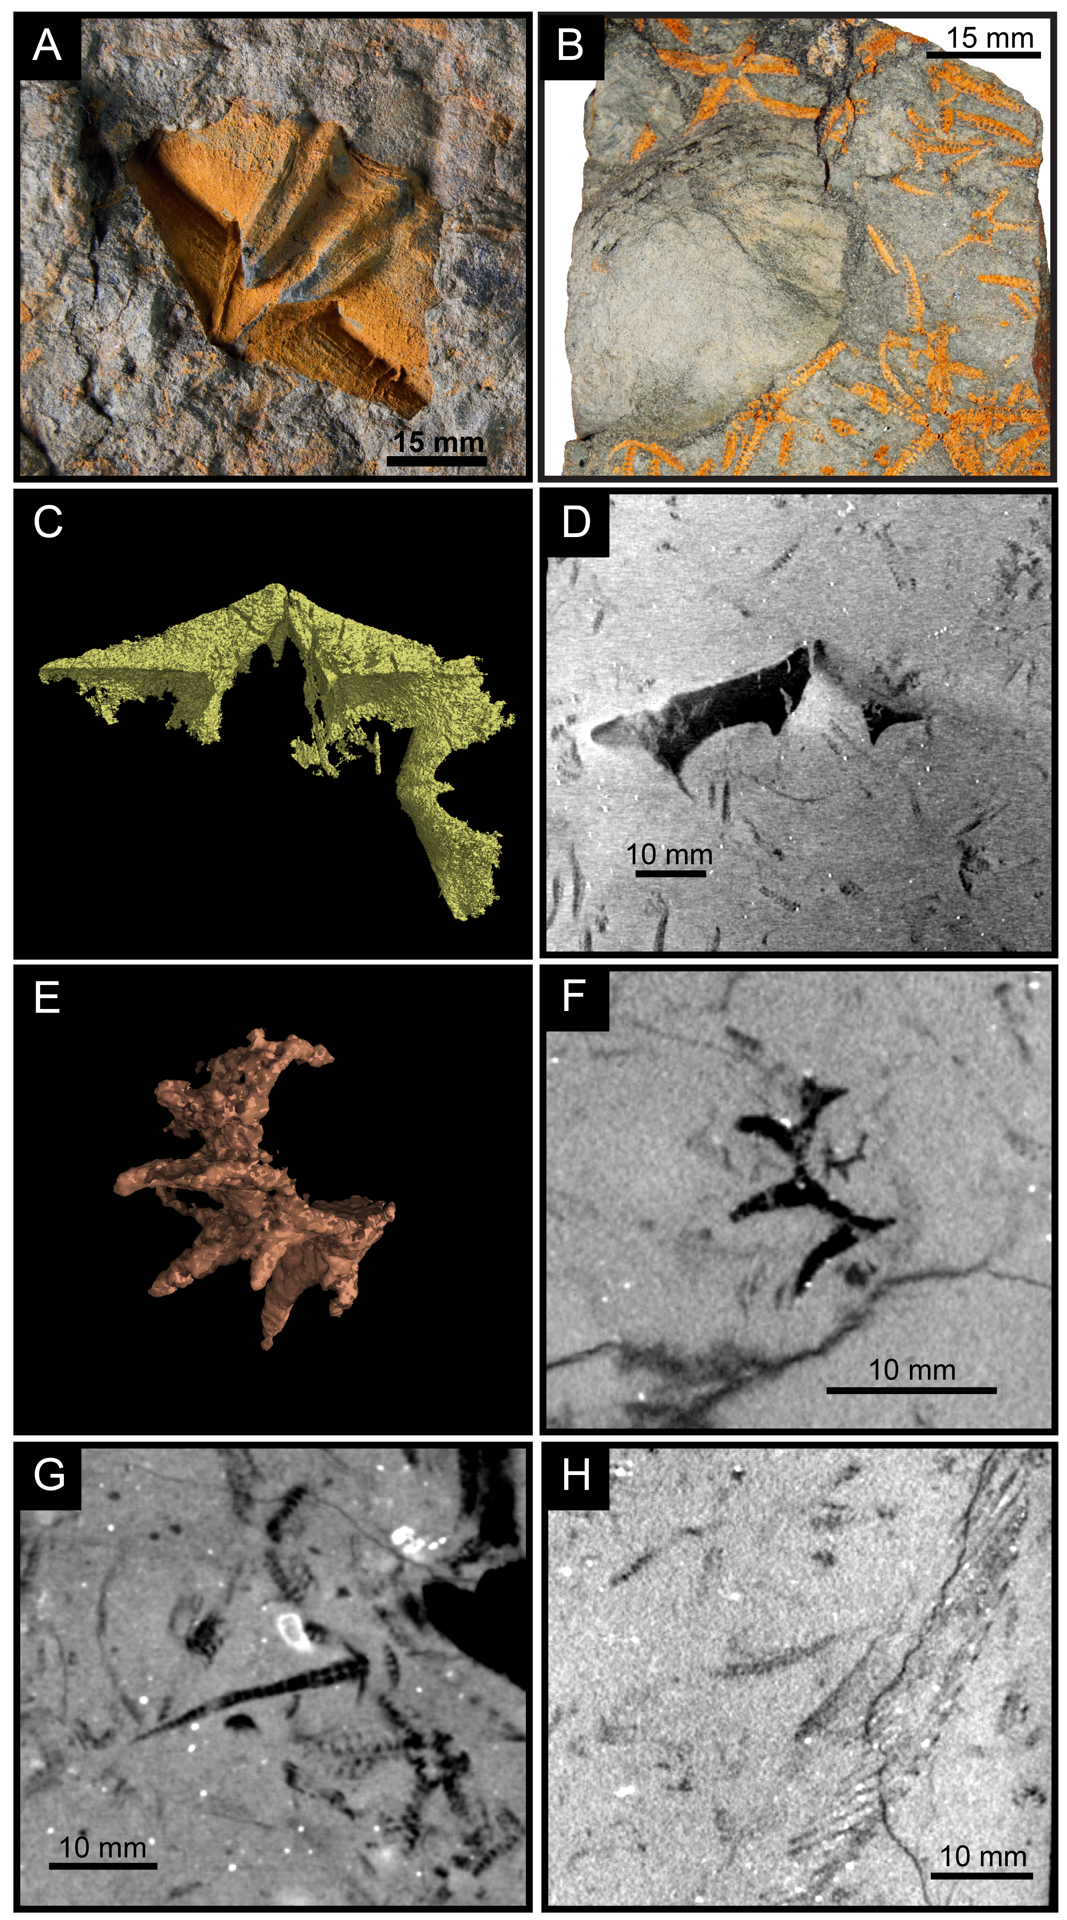

SUPPLEMENTARY FIGURE 4. — Shell specimens in the lower part of Karbonaatjies obrution bed: (A) Pedicle valve of brachiopod Australospirifer sp. (B) Unidentified bivalve possibly Palaeoneilo. Note the articulated ophiuroids surrounding the valve. (C-D) Convex up and convex down pedicle valves of Australospirifer found within the first horizon of ophiuroids. Note that the larger shells are surrounded by ophiuroids and smaller unrecognisable shelly fragments. (E-F) Unidentified gastropod shell fragment with double ridged spines that are similar to Platyceras dumonsum from the Lower Devonian of New York. (G) Fragment of an aulacophore (stylocone, brachial spines and arm ossicles preserved) of probably Placocystella sp. Note the articulated ophiuroid and paranacystid amongst the shell fragments (shadowy marks). (H) Fin spine showing unique comb-like pattern, possibly from a Palaeozoic shark ?Ctenacanthus.
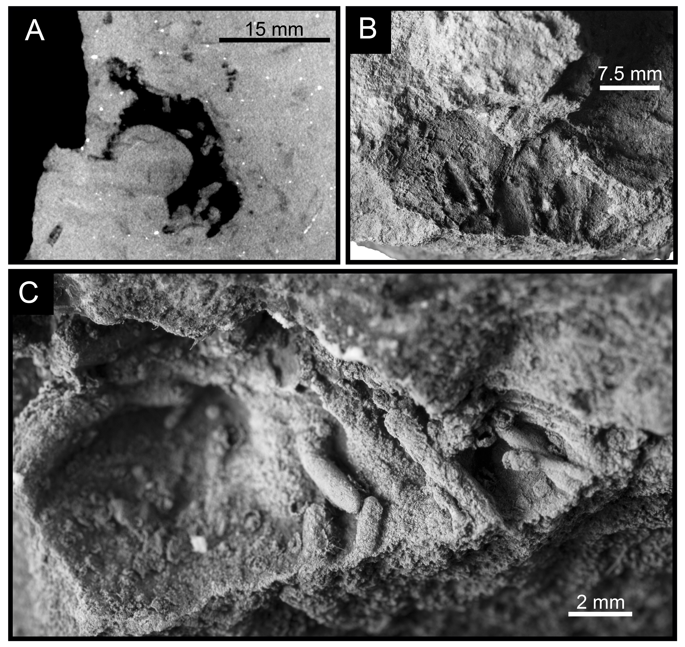
SUPPLEMENTARY FIGURE 5. — Clionoides clarkei (Cameron, 1969) found within 10% of brachiopod valves, mainly the pedicle valves of Australospirifer sp. (A) 2D image scan showing a cross sectional view of sediment filled tunnels in the pedicle valve. (C) Tunnels approximately 1 mm diameter.

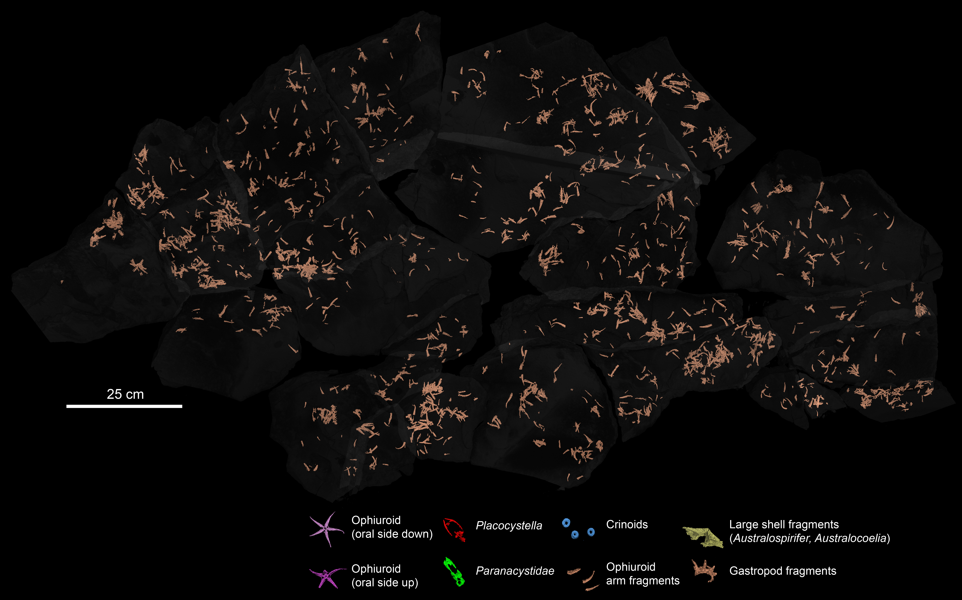
SUPPLEMENTARY FIGURE 6. — Virtual reconstruction of the Karbonaatjies obrution bed shows over 634 fragmented/ isolated arms that are complete or near complete. Arms are distributed randomly throughout the bed and occasionally in dense aggregations. See Figshare: https://doi.org/10.6084/m9.figshare.6216458.v1for high resolution image.
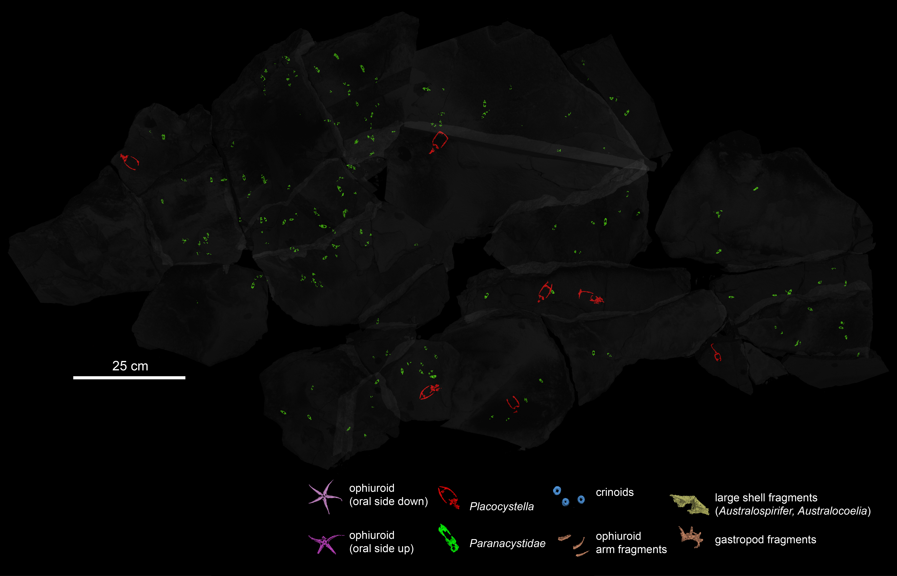
SUPPLEMENTARY FIGURE 6. — Virtual reconstruction of the Karbonaatjies obrution bed shows over 145 articulated Paranacystis cf. petrii Caster, 1954 (green) and eight Placocystella africana (Reed, 1925) (red). See Figshare: https://doi.org/10.6084/m9.figshare.6216458.v1for high resolution image.
SUPPLEMENTARY TABLE 1. — Surface area of the samples versus the number of ophiuroids and stylophorans in the Karbonaatjies obrution bed.
Sample no. | Surface area (mm) | Ophiuroid count  (no. of disks) | Placocystella  africana count  (no. of thecae) | Paranacystid count  (no. of thecae)
A | 177 × 86 | 18 | 0 | 0
BC | 164 × 85 | 64 | 1 | 14
D | 125 × 102 | 33 | 0 | 16
E | 86 × 83 | 21 | 0 | 12
E2 | Not measured | 1 | 0 | 8
F | 102 × 226 | 32 | 0 | 8
F1 | 232 × 115 | 26 | 1 | 0
G | 143 × 55 | 23 | 0 | 17
G2 | 70 × 27 | 0 | 0 | 2
F2 | 117 × 38 | 23 | 0 | 3
F | 85 × 31 | 3 | 0 | 1
M | 129 × 113 | 23 | 0 | 2
K | 182 × 100 | 32 | 0 | 13
WW | 114 × 116 | 32 | 0 | 3
WW2 | 75 × 40 | 10 | 0 | 1
VV3 | 97 × 57 | 16 | 0 | 4
VV2 | 86 × 80 | 26 | 1 | 7
X | 110 × 47 | 6 | 0 | 1
W | 156 × 140 | 47 | 0 | 4
R | 242 × 58 | 46 | 3 | 6
P | 210 × 135 | 66 | 1 | 3
O | 220 × 170 | 34 | 0 | 7
UU | 169 × 80 | 39 | 1 | 9
TT3 | 70 × 90 | 6 | 0 | 0
TT | 149 × 75 | 46 | 0 | 8
SS | 150 × 70 | 24 | 0 | 5
Total | 75 × 45 cm | 714 | 8 | 145

SUPPLEMENTARY TABLE 2. — Taphonomic parameters of ophiuroids from Karbonaatjies obrution bed. Missing data is recorded as n/a, and are due to scans being too faint and/or obscured by artefacts and/or 3D model unclear for measurements.
Sample No. | Ophiuroid arm length (mm) | Ophiuroid disc diameter (mm) | Orientation: oral side up (u), down (d), oblique (o) | Taphonomic grade
A | 17,55 | 6,8 | d | 1
 | 17,33 | 7,21 | u | 1
 | 8,95 | n/a | n/a | 1
 | 9,66 | n/a | d | 1
 | 14,35 | 7,06 | d | 1
 | 17,31 | 6,95 | d | 2
 | 14,8 | 9,17 | d | 1
 | 13,51 | 7,19 | u | 1
 | 14,22 | 7,75 | u | 1
 | 14 | 7 | u | 1
 | 10,2 | 6,37 | u | 1
 | 12,25 | 6,05 | u | 1
 | 19,19 | 9,62 | u | 1
 | 10,24 | 8,2 | u | 2
 | n/a | 7,61 | d | 2
 | 13,41 | 7,16 | u | 1
 | 10,44 | n/a | u | 2
 | 16,6 | 8,02 | d | 1
BC | 8,14 | 9,79 | u | 1
 | 18,34 | 9,26 | d | 1
 | n/a | n/a | o | n/a
 | 12,48 | 6,03 | d | 1
 | 9,36 | 4,54 | d | 1
 | n/a | n/a | n/a | n/a
 | 15,62 | 4,9 | u | 1
 | n/a | n/a | n/a | n/a
 | 11,14 | 5,48 | d | 2
 | 7,69 | 4,93 | d | 2
 | 13,46 | 5,83 | n/a | 2
 | 13 | n/a | d | 1
 | 18 | 9,21 | d | 1
 | 15,57 | 7,77 | d | 1
 | n/a | n/a | d | 2
 | 12,82 | 7,43 | u | 1
 | n/a | n/a | d | 2
 | 23,36 | 9,33 | d | 1
 | 6,2 | 3,55 | d | 1
 | n/a | 6,83 | d | 2
 | n/a | n/a | n/a | 3
 | n/a | n/a | n/a | 3
 | 11,45 | 9,96 | u | 2
 | 12,79 | n/a | d | 1
 | 11,79 | 7,69 | d | 1
 | n/a | n/a | o | 2
 | n/a | n/a | d | 1
 | 15,25 | 6,25 | d | 1
 | n/a | n/a | n/a | 2
 | n/a | n/a | d | n/a
 | 14,48 | n/a | d | 1
 | n/a | n/a | n/a | n/a
 | 4,44 | 2,39 | o | 1
 | 12,13 | 7,4 | d | 1
 | 13,01 | 5,95 | d | 2
 | 9,17 | n/a | d | 2
 | n/a | n/a | n/a | 3
 | 6,05 | 3,13 | d | 1
 | 17,62 | n/a | d | 1
 | n/a | 6,37 | d | 2
 | 15,3 | 5,95 | d | 1
 | 13,59 | 9 | d | 2
 | 10,73 | 4 | u | 2
 | 14,55 | 6 | d | 1
 | 11,68 | 4,92 | d | 1
 | 17,89 | 55,42 | d | 1
 | n/a | 7,12 | u | 1
 | 13,14 | 8,21 | d | 1
 | n/a | n/a | u | 2
 | 13,05 | 7,54 | d | 1
 | 14,98 | n/a | d | 2
 | n/a | n/a | o | 1
 | 12 | 2,72 | d | 2
 | 16,15 | 8,06 | d | 1
 | n/a | n/a | d | 2
 | n/a | 9,01 | u | 1
 | 12 | n/a | u | 2
 | 14,09 | 8,56 | d | 1
 | n/a | n/a | d | 2
 | n/a | 9,11 | u | 1
 | 11 | 9,03 | u | 1
 | 12,41 | n/a | u | 1
 | n/a | n/a | n/a | 2
 | n/a | n/a | o | 1
D | n/a | n/a | n/a | 2
 | 15,38 | 7,64 | u | 1
 | n/a | n/a | d | 2
 | n/a | n/a | n/a | 2
 | n/a | 7,64 | u | 1
 | n/a | n/a | n/a | 1
 | 13,79 | 7,86 | d | 2
 | 11 | 5,5 | d | 2
 | n/a | n/a | n/a | 2
 | n/a | n/a | u | 2
 | n/a | 7,64 | u | 2
 | 13,54 | 5,12 | d | 1
 | n/a | 7,19 | d | 2
 | 21,26 | 7,09 | u | 1
 | n/a | n/a | u | 2
 | 16,29 | 6,37 | d | 1
 | 17,14 | 8,01 | d | 2
 | 17,83 | 10,83 | d | 2
 | 6,77 | 5,35 | u | 2
 | 11,69 | 6,14 | n/a | 2
 | n/a | 6,64 | d | 2
 | n/a | n/a | o | 1
 | n/a | 8,44 | d | 2
 | n/a | 8,59 | d | 2
 | 15,82 | 8,16 | d | 1
 | 13,46 | 4,23 | d | 1
 | 13,57 | 6,02 | u | 1
 | 23,36 | 9,87 | u | 1
 | n/a | 7,28 | d | 2
 | n/a | n/a | o | 1
 | n/a | n/a | o | 2
 | n/a | n/a | d | 2
 | 17,1 | 9,08 | u | 1
E | 6,34 | 2,16 | d | 1
 | 3,36 | 3,3 | d | 1
 | 16,17 | 5,7 | u | 2
 | n/a | n/a | d | n/a
 | n/a | n/a | u | n/a
 | n/a | n/a | u | n/a
 | 9,41 | 6,23 | d | 2
 | 15,48 | 6,23 | d | 1
 | 13,52 | 6,5 | u | 2
 | n/a | n/a | d | n/a
 | n/a | n/a | u | n/a
 | n/a | 3,23 | d | 2
 | n/a | n/a | o | 2
 | 19,75 | 5,34 | u | 2
 | n/a | n/a | n/a | n/a
 | n/a | n/a | n/a | n/a
 | n/a | 5,78 | d | 2
 | n/a | 5,34 | d | 2
 | n/a | n/a | o | 2
 | n/a | 4,27 | d | 1
E2 | n/a | n/a | n/a | 1
F | 11,23 | 6,58 | u | 1
 | 11,38 | 4,38 | d | 2
 | 10,83 | 8,17 | d | 1
 | 16,19 | 5,59 | u | 1
 | 9,63 | 5,95 | d | 1
 | 7,35 | 3,35 | d | 1
 | 7,08 | 3,45 | d | 1
 | 10,26 | 8,05 | u | 2
 | 12,67 | 3,75 | u | n/a
 | 18,58 | 5,38 | u | 1
 | 11,77 | 6,22 | u | 2
 | n/a | 3,18 | u | 2
 | 10,62 | 4,62 | d | n/a 2
 | 5,11 | 2,1 | d | 1
 | 19,21 | 8,46 | d | 1
 | n/a | n/a | u | 2
 | n/a | n/a | d | 1
 | n/a | n/a | d | 2
 | n/a |  | o | 2
 | n/a | n/a | n/a | 3
 | n/a | n/a | n/a | 2
 | n/a | n/a | n/a | 2
 | 15,83 | 7,65 | d | 1
 | n/a | n/a | n/a | 2
 | n/a | n/a | n/a | 2
F1 | 22,29 | 10,2 | u | 2
 | 20 | 8,3 | u | 2
 | 14,23 | 4,62 | u | 2
 | 14,23 | 6,88 | u | 1
 | 14,7 | 8,03 | u | 1
 | 17,84 | 5,53 | d | 1
 |  | 5,8 | u | 3
 | 17,13 | 4,84 | d | 1
 | 16,18 | 7,68 | d | 1
 | 13,22 | 7,41 | d | 2
 | n/a | n/a | o | 1
 | n/a | n/a | o | 1
 | n/a | n/a | u | 2
 | n/a | 7,07 | u | 2
 | n/a | n/a | d | 2
 | 20,38 | 10,52 | d | 1
 | n/a | n/a | d | 2
 | n/a | n/a | d | 1
 | n/a | n/a | d | 2
 | n/a | n/a | d | 1
 | n/a | n/a | o | 1
 | n/a | 6,41 | d | 1
 | 16,05 | 4,42 | d | 1
G | 14,81 | 6,62 | d | 1
 | 13,42 | 6,57 | d | 1
 | 19,57 | 8,83 | d | 1
 | 21,83 | 11,24 | u | 1
 | 16 | 8 | d | 1
 | 18,85 | 9,56 | d | 1
 | 14,96 | 7,88 | d | 1
 | n/a | n/a | d | 1
 | n/a | 4,17 | d | 2
 | n/a | n/a | d | 2
 | n/a | n/a | d | 1
 | 17,81 | 7,81 | u | 1
 | 21,31 | 6,28 | u | 1
 | 5,01 | 2,88 | d | 1
 | n/a | n/a | d | 2
 | 14,87 | n/a | u
 | n/a | 7,02 | u | 2
 | 7,59 | 5,4 | d | 1
 | n/a | n/a | d | 2
 | 15,33 | 8,74 | u | 1
 | 16,94 | 8 | u | 1
F2 | n/a | n/a | o | 1
 | 13,9 | 6,7 | d | 1
 | 10,09 | 5,45 | u | 1
 | 7,17 | 3,74 | u | 1
 | n/a | n/a | o | 1
 | n/a | 7,39 | u | 2
 | n/a | n/a | d | 2
 | n/a | 7,68 | u | 2
 | n/a | n/a | o | 1
 | 18,32 | 7,67 | u | 1
 | n/a | n/a | n/a | 2
 | n/a | n/a | n/a | 2
 | 11,77 | 3,67 | n/a | 1
 | n/a | n/a | u | 3
 | n/a | n/a | o | 1
 | n/a | n/a | o | 1
 | 17,77 | 6,37 | u | 1
 | 7,72 | 4,05 | u | 1
 | n/a | 6,12 | d | 2
 | n/a | n/a | n/a | 2
 | n/a | n/ n/a a | o | 1
 | 1,24 | 2,61 | d | 1
 | n/a | n/a | o | 1
F bottom | n/a | n n/a /a | u | 2
 | 8,04 | n/a n/a | d | 1
M | 14,12 | 8,59 | u | 2
 | 13,57 | 9,9 | u | 2
 | 16,81 | n/a | d | 1
 | 9,46 | 6,01 | u | 2
 | 12,611 | 7,14 | u | 1
 | n/a | n/a | d | 2
 | n/a | n/a | u | 1
 | 14,88 | 5,31 | u | 1
 | n/a | n/a | o | 1
 | n/a | n/a | o | 1
 | 11,54 | n/a | u | 1
 | 15,71 | 8,27 | u | 1
 | n/a | n/a | d | 1
 | n/a | 7,12 | d | 1
 | 15,2 | n/a | o | 1
 | n/a | n/a | u | 3
 | n/a | 8,07 | u | 1
 | n/a | n/a | o | 1
 | 20 | 6,18 | d | 1
 | n/a | 7,43 | u | 2
 | n/A | n/a | n/a | 3
 | 10,78 | 4,48 | d | 1
 | N/A | n/a | n/a | 3
k | 20,7 | 9,58 | u | 1
 | n/a | 5,43 | u | 1
 | 14,95 | 5,48 | u | 1
 | n/a | 5,15 | u | 3
 | 14,31 | n/a | d | 2
 | n/a | n/a | d | 2
 | n/a | 9,8 | u | 1
 | n/a | 8,73 | d | 2
 | n/a | 6,12 | d | 1
 | n/a | 3,8 | d | 2
 | n/a | n/a | d | 1
 | 17,54 | 4,9 | u | 1
 | 16,93 | n/a | d | 1
 | n/a | 4,43 | u | 3
 | 10,08 | n/a | d | 1
 | n/a | 3,91 | u | 1
 | n/a | 4,22 | d | 2
 | n/a | n/a | d | 1
 | 12,79 | n/a | u | 1
 | n/a | n/a | d | 1
 | 17,8 | 8,77 | u | 2
 | 14,57 | 8,57 | u | 1
 | 16,58 | 8,9 | d | 1
 | n/a | 8,47 | d | 2
 | 16,34 | 8,83 | u | 2
 | n/a | n/a | d | 2
 | n/a | n/a | d | 3
 | 19,29 | 7,2 | u | 1
 | 6,54 | 3,04 | d | 1
WW | n/a | n/a | o | 1
 | 17,7 | 6,37 | d | 1
 | n/a | n/a | o | 1
 | n/a | n/a | o | 1
 | 17,02 | 9,95 | d | 1
 | n/a | n/a | o | 1
 | n/a | n/a | u | 2
 | 17,66 | 9,84 | u | 1
 | 17,66 | 9,84 | u | 1
 | n/a | 5,62 | d | 2
 | n/a | 6,47 | d | 1
 | n/a | 4,61 | d | 2
 | 12,84 | 6,99 | u | 1
 | 23,73 | 10,3 | d | 1
 | n/a | n/a | u | 1
 | 19,84 | 11,27 | d | 1
 | 16 | 6,9 | u | 2
 | n/a | 6,27 | n/a | 2
 | n/a | 6,1 | u | 2
 | n/a | n/a | o | 1
 | n/a | n/a | d | 2
 | n/a | n/a | d | 1
 | n/a | n/a | n/a | 1
 | n/a | n/a | o | 1
 | n/a | n/a | o | 1
 | 17,02 | 9,95 | d | 1
 | 11,89 | n/a | d | 1
 | n/a | n/a | o | 1
WW2 | n/a | 14,52 | o | 2
 | n/a | n/a | n/a | 2
 | n/a | n/a | d | 1
 | n/a | n/a | d | 1
 | n/a | n/a | d | 2
 | n/a | n/a | n/a | 1
 | 17,86 | 5,44 | u | 1
 | 21,58 | 5,46 | d | 1
 | n/a | n/a | o | 1
 | n/a | n/a | o | 1
VV3 | 15,83 | 5,01 | d | 1
 | n/a | n/a | d | 2
 | 14,6 | 6,86 | d | 1
 | n/a | n/a | o | 1
 | n/a | n/a | d | 2
 | 14,88 | 6,67 | d | 1
 | 22,06 | 8,23 | d | 1
 | n/a | n/a | d | 1
 | n/a | n/a | o | 1
 | n/a | 2,29 | u | 2
 | n/a | n/a | u | 2
 | n/a | n/a | d | 1
 | n/a | n/a | u | 1
 | n/a | n/a | d | 2
 | n/a | 2,45 | u | 1
 | 7,67 | 2,96 | d | 1
VV2 | n/a | n/a | o | 1
 | 11,4 | 4,84 | d | 1
 | 12 | 8,22 | d | 1
 | n/a | 5,57 | d | 1
 | 16,49 | 7,19 | d | 2
 | n/a | n/a | d | 2
 | 16,93 | 6,78 | d | 1
 | n/a | 6,85 | d | 2
 | n/a | n/a | o | 1
 | n/a | n/a | n/a | 2
 | 15,39 | 6,25 | d | 1
 | n/a | n/a | d | 2
 | n/a | n/a | n/a | 3
 | n/a | n/a | d | 2
 | n/a | n/a | n/a | 2
 | n/a | n/a | d | 2
 | n/a | n/a | o | 1
 | 18,21 | n/a | d | 2
 | 4,22 | 2,57 | d | 1
 | 5,74 | 2,95 | d | 1
 | n/a | 7,22 | u | 3
 | n/a | 5 | u | 2
 | n/a | 7 | d | 2
 | 16 | 7,18 | u | 1
 | 13 | 6,39 | d | 1
 | 16 | 5,15 | d | 1
X | n/a | 6,65 | u | 2
 | 17,54 | n/a | u | 1
 | n/a | n/a | u | 2
 | 18,72 | 9,39 | d | 1
 | 10,4 | n/a | d | 1
 | n/a | 5,53 | u | 1
W | 20,91 | 8,5 | u | 1
 | n/a | 7,16 | u | 3
 | n/a | 7 | u | 3
 | n/a | 8,82 | u | 1
 | 19 | 7,12 | d | 1
 | n/a | 7,12 | o | 1
 | n/a | n/a | d | 1
 | 16,72 | 6,49 | d | 2
 | 13,24 | 5,81 | d | 1
 | 14,98 | 5,11 | u | 2
 | 6 | 3,04 | d | 1
 | n/a | 7,37 | u | 2
 | n/a | n/a | o | 1
 | n/a | n/a | u | 2
 | 15 | 5,2 | d | 2
 | n/a | n/a | o | 1
 | n/a | n/a | d | 2
 | 12 | 6 | d | 1
 | 15,46 | 8,03 | u | 2
 | 13,56 | 7,31 | d | 2
 | n/a | 7,65 | u | 2
 | n/a | n/a | d | 3
 | n/a | 6,38 | d | 2
 | n/a | 7,91 | u | 2
 | 20 | 9,1 | u | 2
 | 17 | 8,29 | u | 1
 | 19 | 9,07 | d | 1
 | n/a | 7,65 | d | 2
 | n/a | 7,62 | d | 2
 | n/a | n/a | n/a | 3
 | n/a | 7,71 | d | 1
 | n/a | 10,14 | d | 2
 | n/a | 7,81 | d | 2
 | 19 | 7,59 | d | 1
 | 16,44 | 8,13 | d | 2
 | 18 | 7,08 | u | 1
 | 18 | 9,55 | d | 1
 | n/a | n/a | n/a | 3
 | n/a | n/a | n/a | 2
 | n/a | n/a | d | 2
 | n/a | 9,25 | d | 2
 | 15,75 | 8,57 | d | 2
 | n/a | n/a | d | 3
 | n/a | n/a | o | 1
 | n/a | 7,37 | u | 2
 | n/a | 6,44 | d | 2
 | 4 | 1,67 | n/a | 1
R | 18,97 | 9,44 | d | 1
 | n/a | 7,9 | d | 2
 | n/a | 10,04 | d | 2
 | n/a | 4,67 | u | 2
 | n/a | 6,29 | u | 2
 | n/a | 7,06 | u | 2
 | n/a | 7,02 | u | 1
 | n/a | n/a | d | ?
 | 12,49 | 6,05 | d | 1
 | n/a | n/a | d | 2
 | n/a | 9,31 | d | 2
 | 18,99 | 8,29 | u | 1
 | n/a | 6,01 | o | 1
 | 13,99 | n/a | u | 1
 | n/a | 7,11 | d | 2
 | n/a | 6,9 | u | 1
 | 17,72 | 7,71 | d | 1
 | n/a | 6 | u | 2
 | n/a | n/a | o | 2
 | n/a | n/a | n/a | 2
 | 17,83 | 6,19 | u | 2
 | n/a | n/a | d | 2
 | n/a | n/a | d | 3
 | n/a | n/a | d | 2
 | n/a | n/a | d | 2
 | 17,04 | 6 | d | 1
 | 7,01 | 2,51 | d | 1
 | n/a | 8,04 | d | 2
 | 4,76 | 2,35 | d | 1
 | n/a | n/a | n/a | 2
 | 6,18 | 2,43 | d | 1
 | n/a | n/a | d | 1
 | n/a | n/a | o | 1
 | 7,5 | 1,9 | u | 1
 | n/a | n/a | d | 2
 | n/a | n/a | o | 1
 | n/a | n/a | d | 1
 | n/a | 5,38 | d | 3
 | n/a | n/a | d | 2
 | n/a | 4,01 | d | 2
 | n/a | 5,63 | d | 1
 | n/a | n/a | o | 1
P | n/a | 6,91 | u | 3
 | 17,25 | 8,27 | u | 1
 | 5,33 | 3,06 | d | 1
 | 6,24 | n/a | o | 1
 | n/a | n/a | d | 2
 | 18,82 | 8,43 | u | 1
 | 18,25 | 8,31 | d | 1
 | n/a | 8,04 | d | 3
 | 8,9 | 4,37 | d | 1
 | n/a | 8,49 | u | 2
 | n/a | n/a | d | 2
 | n/a | 8,38 | u | 2
 | n/a | n/a | d | 2
 | n/a | n/a | u | 2
 | 18,68 | 7,25 | d | 1
 | 3,98 | 2,1 | d | 1
 | 17 | 9,11 | d | 1
 | 15,74 | 6,92 | d | 1
 | 19,22 | 9,1 | u | 1
 | 15,28 | 7,44 | u | 2
 | n/a | n/a | d | 2
 | 17,96 | 6,74 | d | 2
 | n/a | 7,52 | u | 2
 | n/a | 9,53 | d | 2
 | n/a | 8,36 | d | 1
 | 8,56 | 4,15 | d | 2
 | n/a | 8 | u | 2
 | n/a | 8 | u | 2
 | n/a | 8,3 | d | 3
 | n/a | n/a | d | 2
 | n/a | n/a | d | 3
 | n/a | 7,56 | d | 1
 | n/a | n/a | u | 2
 | 5,78 | 2,7 | d | 1
 | 2,27 | 1,45 | d | 1
 | n/a | n/a | u | 2
 | 16,44 | 8,5 | d | 1
 | n/a | n/a | u | 2
 | 8,54 | 4,89 | d | 1
 | 15,57 | 8,26 | u | 1
 | 15,57 | n/a | d | 1
 | n/a | n/a | d | 1
 | n/a | n/a | d | 1
 | n/a | n/a | o | 1
 | n/a | n/a | u | 2
 | n/a | n/a | d | 1
 | n/a | n/a | d | 2
 | n/a | n/a | o | 1
 | n/a | n/a | o | 1
 | n/a | n/a | o | 1
 | n/a | n/a | o | 1
 | n/a | 2,21 | d | 1
 | n/a | n/a | o | 1
 | 5,71 | 3,14 | d | 1
 | 7,88 | 3,52 | d | 1
 | 3,02 | 1,77 | d | 1
 | 6,54 | n/a | o | 1
 | n/a | n/a | o | 1
 | n/a | 2,32 | d | 1
 | n/a | n/a | o | 2
 | 2,53 | 1,78 | d | 1
 | n/a | n/a | o | 1
 | n/a | n/a | o | 1
O | 21,23 | 10,93 | d | 1
 | 14,28 | 7,37 | d | 1
 | n/a | n/a | o | 2
 | n/a | 5,58 | u | 2
 | 17,92 | 6,58 | u | 2
 | 6,37 | 3,06 | d | 1
 | 8,23 |  | o | 1
 | 16,25 | 9,71 | d | 1
 | 4,63 | 2,65 | d | 1
 | 19,26 | 6,87 | d | 2
 | 9,85 | 4,97 | d | 2
 | 16,02 | 6,38 | d | 1
 | n/a | n/a | d | 2
 | n/a | n/a | o | 1
 | n/a | n/a | o | 2
 | 17,19 | 7,39 | u | 1
 | 15,76 | 8,03 | d | 1
 | n/a | 7,93 | u | 1
 | n/a | n/a | u | 2
 | n/a | n/a | o | 2
 | n/a | 6,84 | u | 1
 | n/a | n/a | o | 1
 | n/a | n/a | u | 2
 | n/a | n/a | d | 2
 | n/a | n/a | u | 2
 | n/a | n/a |  | 2
 | n/a | n/a | o | 1
 | n/a | n/a | u | 2
 | n/a | n/a |  | 3
 | n/a | n/a | o | 1
 | 13,45 | n/a | o | 1
 | 16,65 | n/a | d | 1
 | n/a | 2,72 | u | 1
 | n/a | 5,93 |  | 3
UU | n/a | 7,11 | u | 2
 | n/a | 6,27 | u | 2
 | n/a | 2,99 | d | 2
 | n/a | 8,39 | d | 2
 | n/a | 6,8 | o | 2
 | n/a | 7,72 | d | 2
 | n/a | 7,23 | d | 2
 | n/a | 9,98 | u | 2
 | n/a | n/a | o | 1
 | n/a | n/a | o | 1
 | n/a | n/a | o | 2
 | n/a | n/a | u | 2
 | n/a | 6,4 | d | 2
 | n/a | 6,37 | d | 2
 | n/a | 5,87 | u | 2
 | n/a | n/a | d | 2
 | n/a | n/a | d | 3
 | n/a | 9.84 | u | 2
 | n/a | n/a | d | 2
 | n/a | 6.38 | d | 2
 | n/a | n/a | d | 2
 | n/a | n/a | o | 2
 | 17.04 | 6.44 | d | 1
 | n/a | 7.06 | u | 2
 | n/a | n/a | o | 2
 | 16.80 | 6,16 | u | 1
 |  | 3,62 | d | 2
 | 6,26 | 3,35 | d | 1
 | n/a | n/a | o | 2
 | n/a | 7,27 | d | 2
 | n/a | n/a | o | 1
 | n/a | n/a | d | 2
 | n/a | 5,22 | d | 1
 | n/a | 6,16 | u | 2
 | n/a | n/a | d | 3
 | 2,51 | 2,38 | d | 1
 | n/a | n/a | d | 2
 | n/a | 8,28 | u | 2
 | 3,48 | 2,68 | d | 1
UU2 | 16,84 | 7,12 | d | 1
 | n/a | n/a | d | 2
 | n/a | n/a | o | 1
 | n/a | 5,28 | d | 2
 | n/a | n/a | o | 1
 | n/a | 6,93 | u | 2
 | n/a | 7,11 | u | 2
 | n/a | 8,96 | u | 2
 | n/a | 6,83 | u | 2
 | 19,67 | 6 | d | 1
TT3 | n/a | 6,66 | d | 1
 | n/a | n/a | d | 2
 | n/a | n/a | d | 2
 | n/a | 6 | u | 2
 | n/a | n/a | o | 1
 | n/a | 3,02 | d | 1
TT2 | n/a | 8,32 | u | 2
 | n/a |  | d | 1
 | 5,1 | 2,85 | d | 1
 | 17,08 |  | d | 1
 | 7,47 | 3,57 | d | 1
 | 16,92 | 6,77 | u | 1
 | 3,27 | 1,9 | d | 1
TT | n/a | 7,14 | u | 1
 | n/a | n/a | d | 1
 | n/a | 6,54 | d | 2
 | n/a | 7,26 | u | 1
 | 19 | 8,41 | u | 1
 | n/a | n/a | o | 1
 | n/a | 6,94 | d | 1
 | 17 | 8,3 | u | 1
 | n/a | n/a | d | 1
 | n/a | 9,35 | d | 2
 | n/a | 7,99 | d | 1
 | n/a | n/a | d
 | n/a | 6,09 | d | 1
 | n/a | 6,42 | d | 2
 | n/a | 7,18 | d | 1
 | n/a | 6,09 | d | 1
 | n/a | 6,81 | u | 1
 | n/a | 6,54 | u | 2
 | 5,88 | 2,36 | d | 1
 | n/a | n/a | o | 1
 | n/a | n/a | o | 1
 | 17,73 | 8,23 | d | 1
 | n/a | n/a | d | 3
 | 19,52 | 8,05 | u | 2
 | n/a | 7,24 | d | 2
 | n/a | 6,66 | u | 2
 | n/a | 10,37 | d | 2
 | 17 | 8,18 | d | 1
 | 9,1 | 3,39 | d | 1
 | 4,57 | 3,37 | d | 1
 | 18,57 | 8,1 | d | 2
 | 20,14 | 8,82 | d | 1
 | 20,14 | 8,82 | d | 1
 | 3,04 | 1,89 | d | 1
 | n/a | 6,64 | d | 1
 | n/a | 8,89 | d | 2
 | n/a | 5,39 | o | 1
 | n/a | n/a | d | 1
 | n/a | 7,26 | d | 2
 | n/a | 8,72 | u | 2
 | n/a | 6,15 | d | 2
 | n/a | 8,4 | u | 2
 | n/a | n/a | o | 2
 | n/a | 7,41 | d | 1
 | n/a | 7,35 | d | 2
 | n/a | n/a | o | 1
SS | n/a | 7,79 | u | 3
 | n/a | 3,46 | d | 2
 | 15,63 | 8,66 | u | 2
 | 22,17 | 8,86 | u | 1
 | 3 | 2,98 | d | 1
 | 3,54 | 2,84 | d | 1
 | n/a | n/a | u | 2
 | 8,09 | 3,41 | d | 1
 | n/a | 6,47 | d | 2
 | n/a | n/a | o | 2
 | n/a | n/a n/a | u | 2
 | 16,05 | 7,04 | u | 1
 | n/a |  | d | 2
 | n/a | n/a | d | 2
 | 23,47 | n/a | d | 2
 | 7 | 3,45 | d | 1
 | 18 | 8,45 | u | 2
 | 8,31 | 5 | d | 1
 | 20,2 | 7,93 | u | 1
 | n/a | 7,47 | u | 1
 | n/a | 11,11 | u | 2
 | n/a |  | d | 2
 | n/a | n/a | o | 2
 | 2,73 | 2,15 | d | 1

SUPPLEMENTARY TABLE 3. — Measured thecal width versus length of the paranacystids in each sample as well as orientation of the aulacophore and taphonomic grade. Missing data recorded as n/a and are due to scans being too faint and/or obscured by artefacts and/or 3D model unclear for measurements.
Sample No. | Thecal width (mm) | Thecal length (mm) | Orientation of aulacophore | Taphonomic grade
BC | 2,51 | 4,2 |  | 1
 | 1,71 | 4 | over theca (top) | 1
 | 2,15 | 4,08 |  | 1
 | 1,79 | 4,37 | curved to side | 1
 | 1,89 | 3,87 |  | 1
 | 2,36 | 3,7 | over theca (top) | 1
 | 1,73 | 3,49 | over theca (bottom) | 1
 | 2,11 | 3,8 |  | 1
 | n/a | n/a |  | 2
 | 2,2 | 3,74 | over theca (bottom) | 1
 | 2,1 | 4 |  | 1
 | 1,35 | 4,03 | curved to side | 1
 | 1,36 | 3,18 | stretch out | 1
 | 2,38 | 3,21 |  | 1
D | 2,15 | 3,78 | over theca (top) | 1
 | 2,13 | 4,35 |  | 2
 | 2,39 | 3,79 |  | 1
 | 1,79 | 3,55 |  | 1
 | 2,03 | 4,35 |  | 1
 | n/a | n/a |  | 2 (too faint)
 | 1,84 | 3,98 |  | 2 (too faint)
 | 2,01 | 4,08 |  | 1
 | 2,42 | 4,61 | curved to side | 1
 | 2,07 | 3,82 |  | 1
 | 2,08 | 3,79 |  | 1
 | n/a | n/a |  | 2 (no theca)
 | 2,49 | 4,57 | curved to the side | 1
 | 2,27 | 4,55 | curved to side
 | n/a | n/a |  | 2 (no theca)
E | n/a | n/a |  | 2
 | 1,64 | 3,55 | arm over theca (top) | 1
 | 1,86 | 3,75 |  | 1
 | n/a | n/a |  | 2
 | 1,25 | 3,94 | arm curved to side | 1
 | 2,35 | 4,52 | arm over theca (bottom) | 1
 | n/a | 3,94 | arm curved to side | 1
 | n/a | n/a |  | 2
 | 3,47 | 2,24
 | 2,14 | 4,99 | arm stretch out | 1
 | 2,65 | 4,82 |  | 1
E2 | 2,29 | 3,78 | arm curved to side | 1
 | 1,68 | 3,6 |  | 1
 | 1,78 | 3,6 |  | 1
 | n/a | n/a |  | 2(no theca)
 | 1,62 | 2,69 |  | 1
 | 2,09 | 3,26 |  | 1
 | 1,7 | 2,98 | arm curved to side | 1
 | 2,13 | 3,37 | arm curved to side possible digit?? | 1
F | 0,99 | 1,95 |  | 1
 | 2,28 | 4,79 | arm curved to side | 1
 | n/a | 3,59 |  | 2
 | 2,07 | 3,49 |  | 1
 | 1,35 | 3,18 |  | 1
 | 1,7 | 3,99 |  | 1
 | 1,9 | 2,89 |  | 1
 | 2,01 | 4,25 |  | 1
G | 2,11 | 3,49 | arm curved to side | 1
 | 2,61 | 5,23 | arm flexed up (top) | 1
 | 1,33 | 3,14 | no arm | 2
 | 1,72 | 3,59 | no arm | 2
 | n/a | n/a | no theca just aulco | 2
 | 1,82 | 3,83 |  | 1
 | 2,71 | 4,81 |  | 1
 | 1,38 | 3,75 |  | 1
 | n/a | 4,21 |  | 2
 | 1,96 | 4,8 | arm curved to side | 1
 | 1,93 | 3,8 | arm curved to side | 1
 | 1,11 | 3,13 | on its side | 1
 | 2,25 | 4,01 | arm stretched out | 1
 | n/a | n/a | no theca | 2
 | 1,61 | 2,27 | no arm but aulco | 1
 | 1,97 | 2,88 |  | 1
 | 2,48 | 4,22 |  | 1
G2 | 1,91 | 3,34 |  | 1
 | 3,28 | 5,37 |  | 1
F2 | 2,37 | 3,91 | arm curved to side | 1
 | 1,5 | 3,12 |  | 1
 | 2,09 | 4,97 | arm flexed up (top) | 1
F bottom | 1,59 | 3,42 | no auclophore | 2
M | 1,19 | 4,4 |  | 1
 | 2,81 | 5,5 |  | 1
K | 1,55 | 2,87 |  | 1
 | 1,87 | 4,38 | arm flexed up (bottom) | 1
 | 2,37 | 4,68 |  | 1
 | n/a | 4,78 |  | 1
 | 1,88 | 3,85 | flexed up top | 1
 | 2,43 | 4,3 |  | 1
 | 1,34 | 3,27 |  | 1
 | 2,16 | 3,53 |  | 1
 | n/a | 4,51 |  | 1
 | n/a | n/a |  | 2
 | 2,4 | 4,95 | flexed up top | 1
WW | 2,3 | 4,95 |  | 1
 | 1,87 | 4,95 | curved to side | 1
 | 2,1 | 4,53 | flexed over theca (up) | 1
WW2 | 2,14 | 4,95 | flexed under | 1
VV3 | 1,85 | 4,81 | curved under | 1
 | n/a | n/a |  | 2
 | 1,65 | 3,27 | curved under | 1
 | n/a | 3,98 | curved to side | 1
VV2 | 1,91 | 4,14 | curved up | 1
 | 2,38 | 5,56 | curved to side | 1
 | 2,19 | 4,3 |  | 1
 | 2,18 | 5,51 | curved under | 1
 | 2,03 | 3,1 | curved arm | 1
 | 2,51 | 5,38 | curved arm | 1
 | 1,91 | 3,47 |  | 1
X | 2,17 | 4,41 |  | 1
W | 2,48 | 4,92 |  | 1
 | 1,89 | 3,26 | arm | 1
 | 2,19 | 3,85 |  | 1
 | 2,11 | 5,01 |  | 1
R | 2,12 | 5,27 | flexed over theca top | 1
 | 2,03 | 4,53 |  | 1
 | 1,98 | 4,78 |  | 2
 | 2,44 | 4,75 | curved under theca | 1
 | 2,81 | 4,8 | curved to the side | 1
 | n/a | 2,57 |  | 2
P | n/a | 5,71 | on its side, arm on side | 1
 | 2,27 | 4,61 | curved to side | 1
 | 1,92 | 5,41 |  | 1
O | 2,3 | 5,53 | curved under | 1
 | 2,71 | 4,85 | curved to the side | 1
 | n/a | 4,78 |  | 1
 | 2,3 | 4,38 | curved up | 1
 | 2,22 | 4,18 |  | 1
 | 1,79 | 3,58 | curved to side | 1
 | 1,69 | 3,39 |  | 1
UU | 2 | 3,96 |  | 1
 | 2,36 | 4,4 | curved up | 1
 | 2,17 | 4,87 | curved up | 1
 | 2,13 | 5,87 |  | 1
 | 1,41 | 2,54 |  | 1
 | 2,65 | 4,15 |  | 2
 | 1,66 | 3,99 |  | 1
 | 2,36 | 4,73 | curved to side | 1
 | 2,68 | 4,66 | curved up | 1
TT2 | 1,92 | 4,81 | curved to side | 1
TT | 2,54 | 4,93 | curved to side | 1
 | 2,64 | 4,41 | flexed up top | 1
 | 2,37 | 3,39 |  | 1
 | 1,73 | 3,08 |  | 1
 | 1,96 | 3,2 | flexed up top | 1
 | 1,93 | 3,16 |  | 1
 | 2,2 | 4,57 | curved to side | 1
 | 2,16 | 4,08 | curved to side | 1
SS | 1,73 | 3,89 |  | 1
 | 1,88 | 3,85 |  | 1
 | 2,5 | 5 | curved up | 1
 | 1,98 | 4,68 | curved to side | 1
 | 1,37 | 2,86 |  | 1

SUPPLEMENTARY TABLE 4. — Measured thecal width versus length of the Placocystella in each sample as well as orientation defined by the position of the brachial and taphonomic grade. Missing data recorded as n/a and are due to scans being too faint and/or obscured by artefacts and/or 3D model unclear for measurements
Sample No. | Thecal width (mm) | Thecal length (mm) | Orientation | Taphonomic grade
BC | 10,41 | 13,14 | brachial down | 1
F1 | 8,83 | 13,42 | brachial down | 2
VV2 | 10,21 | 13,32 | brachial down | 1
W | 9,13 | 12,15 | n/a | 1
R | 8,73 | 13,77 | n/a | 2
 | 9,37 | 12,79 | n/a | 1
P | 9,46 | 11,72 | n/a | 2
UU2 | 6,45 | 6,18 | brachial up | 1

SUPPLEMENTARY TABLE 5. — Basic statistics and results of normality tests.
 | Ophiuroids | Paranacystids
N | 415 | 139
Min | 1,45 | 1,95
Max | 14,52 | 5,87
Mean | 6,577831 | 4,078489
Median | 6,88 | 4,01
Std. error | 0,1052746 | 0,066476
Stand. dev | 2,144606 | 0,783736
Skewness | -0,2998331 | -0,1185
Kurtosis | -0,05621089 | -0,31847
Shapiro-Wilk W | 0.9754 | 0.9921
Shapiro-Wilk Probability | 1.769E-06 | 0.6274

SUPPLEMENTARY TABLE 6. — Taphonomic parameters of brachiopods extracted from Karbonaatjies obrution bed. All shells are disarticulated. Missing data recorded as n/a and are due to scans being too faint and/or obscured by artefacts and/or 3D model unclear for measurements.
Sample no. | Fragmentation |  | Brachial (b) or pedical (p) valve | Convex up (u) or down (d) | Orientation |  | Borings | Valve length (mm) | Valve width (mm)
Z | low | p |  | n/a | v |  |  | 65 | n/a
XX | high | p |  | u | h |  |  | n/a | n/a
 | high | p |  | d | h | yes |  | n/a | n/a
F1 | moderate | p |  | d | h |  |  | 54,1 | 22,48
 | high | n/a |  | u | h |  |  | n/a | n/a
 | moderate | p |  | u | h |  |  | n/a | n/a
G | moderate | p |  | u | h |  |  | n/a | n/a
 | high | p |  | u | h |  |  | n/a | n/a
UU | high | n/a |  | n/a | n/a | yes |  | n/a | n/a
F | high | b |  | d | h |  |  | n/a | 30
 | high | p |  | u | h |  |  | n/a | n/a
OO | high | p |  | d | h |  |  | n/a | n/a
RR | moderate | p |  | u | h |  |  | 43,15 | n/a
 | high | p |  | u | h |  |  | 33,53 | n/a
Fb | moderate-h | p |  | d | h |  |  | 3,5 | 2
 | m-h | b |  | u | h |  |  | n/a | n/a
P | mod | p |  | d | h |  |  | 61,34 | n/a
CC | m-h | b |  | u | h |  |  | n/a | n/a
PP | m-h | p |  | d | h |  |  | n/a | n/a
 | m-h | p |  | d | h |  |  | n/a | n/a
Q | m-h | b |  | u | h | yes |  | n/a | n/a
J | m-h | p |  | u | h |  |  | n/a | n/a
 | m-h | b |  | u | h | yes |  | n/a | n/a
HH | m-h | p |  | u | h |  |  | n/a | n/a
 | m-h | p |  | d | h |  |  | n/a | n/a
EE | m-h | p |  | u | h |  |  | n/a | n/a
 | m-h | b |  | u | h |  |  | n/a | n/a
QQ | m-h | p |  | d | h |  |  | n/a | n/a
K | high | n/a |  | u | sub-h | yes |  | n/a | n/a
 | high | n/a |  | u | h | yes |  | n/a | n/a
 | high | n/a |  | u | h | yes |  | n/a | n/a
AA | m | p |  | u | h | yes |  | 55 | n/a
LT | m | p |  | d | h |  |  | 18,35 | 7,18
CC2 | L-m | p |  | d | h |  |  | 63 | 34
 | L-M | p |  | d | h |  |  | 42 | 22,3
W2 | m | p |  | d | h | yes |  | 23,84 | n/a
N | m | p |  | d | h |  |  | 33,7 | n/a
SS | m | p |  | u | h | yes |  | 30,26 | 23,57
 | m | p |  | d | h |  |  | 52,98 | 40,47
Y | l-m | p |  | d | h |  |  | 62,97 | 32,86
JJ | m | p |  | u | h | yes |  | 52,64 | 17.59
GG | m-h | p |  | u | h |  |  | n/a | n/a

SUPPLEMENTARY TABLE 7. — Taphonomic parameters of bivalves extracted from Karbonaatijies obrution bed. All shells are disarticulated. Missing data recorded as n/a and are due to scans being too faint and/or obscured by artefacts and/or 3D model unclear for measurements.
Sample no. | Fragmentation | Right (R) or left (L) valve | Convex up (u) or down (d) | Orientation | valve length (cm) | valve width (cm)
F1 | high | n/a | n/a | h | n/a | n/a
 | high | R | u | h | n/a
G | high | n/a | d | h | n/a | n/a
UU | low | R | u | h | 4 | 3
F | moderate | L | u | h | n/a | n/a
ZZ | moderate | R | u | h | n/a | n/a
RR | low | L | u | h | 3 | 2
XX | low | L | u | h | n/a | n/a

