SUPPLEMENTARY MATERIALS

Jenkins, C.J. 2018. “Sediment Accumulation Rates for the Mississippi Delta Region: A Time-Interval Synthesis”

Figure S1. Plot of the Sadler Effect coefficients Intercept and Slope for various divisions of the data, illustrating the scope of their variability. The error bars show the 1σ level of Standard Deviation on each coefficient, calculated from the Standard Error of the regression on the log10 raw data values. The divisions are denoted as follows: prodelta – prodelta area of the Mississippi Delta; bay – an enclosed marine area; canyon – submarine canyon area; shoreline – shore zones of land or offshore islands, including barrier islands; shelf – continental shelf, broadly; deeps – all areas deeper than the continental shelf; (for example) 25_wd_80 –for all data in areas between 25 and 80m WD; (for example) 33_mud_66 – all data in areas with between 33 and 66% mud contents according to dbSEABED griddings (Jenkins ) ; raw_by_codes – all the data.
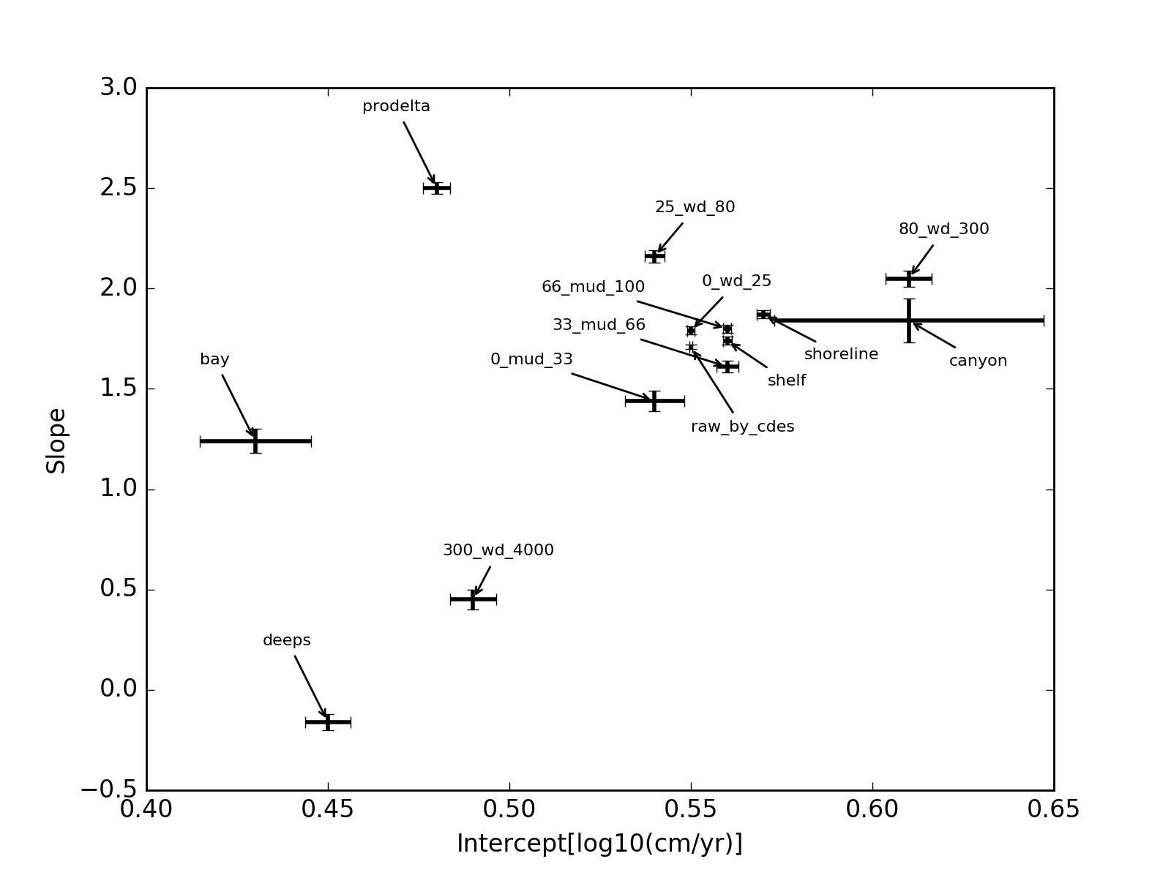
Table S1. Sadler Effect coefficients for divisions of the data by WD and province. (* Values have units of log10_cm/yr.)

Parameter:  Division: | Slope (β’) | Intercept (α*) | Intercept LAR (cm/yr) | R² | N | stdErr | SD Intercept (*) | SD Slope
All data | 0.55 | 1.71 | 51.3 | 0.66 | 717 | 0.01 | 0.0004 | 0.0001
0_wd_25 | 0.55 | 1.79 | 61.7 | 0.73 | 388 | 0.02 | 0.0011 | 0.0003
25_wd_80 | 0.54 | 2.16 | 144.5 | 0.66 | 156 | 0.03 | 0.0027 | 0.0008
80_wd_300 | 0.61 | 2.05 | 112.2 | 0.74 | 71 | 0.04 | 0.0064 | 0.0017
300_wd_4000 | 0.49 | 0.45 | 2.8 | 0.5 | 114 | 0.05 | 0.0063 | 0.0016
shoreline | 0.57 | 1.87 | 74.1 | 0.79 | 163 | 0.02 | 0.0018 | 0.0005
bay | 0.43 | 1.24 | 17.4 | 0.55 | 43 | 0.06 | 0.0153 | 0.0038
prodelta | 0.48 | 2.5 | 316.2 | 0.75 | 100 | 0.03 | 0.0037 | 0.0010
shelf | 0.56 | 1.74 | 55.0 | 0.67 | 292 | 0.02 | 0.0012 | 0.0003
deeps | 0.45 | -0.16 | 0.7 | 0.68 | 79 | 0.04 | 0.0063 | 0.0015
canyon | 0.61 | 1.84 | 69.2 | 0.55 | 26 | 0.11 | 0.0371 | 0.0100
0_mud_33 | 0.54 | 1.44 | 27.5 | 0.64 | 67 | 0.05 | 0.0082 | 0.0018
33_mud_66 | 0.56 | 1.61 | 40.7 | 0.75 | 118 | 0.03 | 0.0030 | 0.0008
66_mud_100 | 0.56 | 1.8 | 63.1 | 0.66 | 436 | 0.02 | 0.0010 | 0.0003

Supplementary: Data References
Allison, M.A., Bianchi, T.S., McKee, B.A., and Sampere, T.P. 2007, Carbon burial on river-dominated continental shelves: Impact of historical changes in sediment loading adjacent to the Mississippi River: Geophysical Research Letters, v. 34, no. L01606, doi: 10.1029/2006GL028362.
Allison, M.A., Dellapenna, T.M., Gordon, E.S., Mitra, S., and Petsch, S.T. 2010, Impact of Hurricane Katrina (2005) on shelf organic carbon burial and deltaic evolution: Geophysical Research Letters, v. 37, p. L21605, doi: 10.1029/2010GL044547.
Allison, M.A., Kineke, G.C., Gordon, E.S., and Goñi, M.A. 2000, Development and reworking of a seasonal mud deposit on the inner continental shelf off the Atchafalaya River: Continental Shelf Research, v. 20, p. 2267-2294.
Anderson, J.B., and Rodriguez, A.B. 2008. Response of Upper Gulf Coast Estuaries to Holocene Climate Change and Sea-level Rise: Geological Society of America Special Paper 443, 146 pp.
Bentley, S.J., Furukawa, Y., and Vaughan, W.C. 2000, Record of Event Sedimentation in Mississippi Sound: Gulf Coast Association of Geological Societies Transactions, v. 50, p. 715-724.
Bentley, S.J., Keen, T.R., Blain, C.A., and Vaughan W.C. 2002, The origin and preservation of a major hurricane event bed in the northern Gulf of Mexico: Hurricane Camille, 1969: Marine Geology, v. 186(3–4), p. 423–446.
Bianchi, T.S., Allison, M.A., Canuel, E.A., Corbett, D.R., McKee, B.A., Sampere, T.P., Wakeham, S.G., and Waterson, E. 2006, Rapid Export of Organic Matter to the Mississippi Canyon: EOS, v. 87(50), p. 565–573.
Bianchi, T.S., Mitra, S., and McKee, B.A. 2002, Sources of terrestrially-derived organic carbon in lower Mississippi River and Louisiana shelf sediments: implications for differential sedimentation and transport at the coastal margin: Marine Chemistry, v. 77, p. 211-223.
Bregy, J.C. 2016, Determining the Viability of Recent Storms as Modern Analogues for North- Central Gulf of Mexico Paleotempestology through Sedimentary Analysis and Storm Surge Reconstruction: University of Southern Mississippi, Mississippi, USA, Master's Theses, Paper no. 198, 64 pp., [Available: http://aquila.usm.edu/masters_theses/198 , accessed 07 December 2016].
Brooks, G.R., Larson, R.A., Schwing, P.T., Romero, I., Moore, C., Reichart, G.-J., Jilbert, T., Chanton, J.P., Hastings, D.W., Overholt, W.A., Marks, K.P., Kostka, J.E., Holmes, C.W., and Hollander, D. 2015, Sedimentation Pulse in the NE Gulf of Mexico following the 2010 DWH Blowout: PLoS ONE, v. 10(7), no. e0132341, doi: 10.1371/journal.pone.0132341
Chmura, G.L., and Kosters, E.C. 1994, Storm Deposition and ¹³⁷Cs Accumulation in Fine-grained Marsh Sediments of the Mississippi Delta Plain: Estuarine, Coastal and Shelf Science, v. 39, p. 33-44.
Continental Shelf Associates, Inc. 2004, Final Report. Gulf of Mexico Comprehensive Synthetic Based Muds Monitoring Program. Volume II: Technical. October 2004: Prepared for SSM Research Group by Continental Shelf Associates Inc., Jupiter, Florida, USA, 358 pp.
Continental Shelf Associates, Inc. 2004, Final Report. Gulf of Mexico Comprehensive Synthetic Based Muds Monitoring Program: Prepared for SBM Research Group, 14 pp, Available: http://www.nodc.noaa.gov/archive/arc0031/0069470/1.1/data/0-data/Executive%20Summary%20Volume.pdf, Accessed 06 Dec 2016.
Corbett R., McKee, B.A., and Duncan, D. 2004, An evaluation of mobile mud dynamics in the Mississippi River deltaic region: Marine Geology, v. 209, p. 91-112.
Corbett, D.R., Dail, M., and McKee, B. 2007, High-frequency time-series of the dynamic sedimentation processes on the western shelf of the Mississippi River Delta: Continental Shelf Research, v. 27, p. 1600–1615.
Corbett, D.R., McKee, B., and Allison, M. 2006, Nature of decadal-scale sediment accumulation on the western shelf of the Mississippi River delta: Continental Shelf Research, v. 26, p. 2125–2140.
Dail, M.B., Corbett, D.R., and Walsh, J.P. 2007, Assessing the importance of tropical cyclones on continental margin sedimentation in the Mississippi delta region: Continental Shelf Research, v. 27, p. 1857–1874.
DeLaune, R.D. 1988, Processes of Formation and Degradation of Marshes along the Louisiana Gulf Coast: Doctoral thesis, Wageningen University, The Netherlands, 171 pp.
DeLaune, R.D., Smith, C.J., Patrick Jr, W.H., and Roberts, H.H. 1987, Rejuvenated Marsh and Bay-bottom Accretion on the Rapidly Subsiding Coastal Plain of U.S. Gulf Coast: a Second-order Effect of the Emerging Atchafalaya Delta: Estuarine, Coastal and Shelf Science, v. 25, p. 381-389.
Draut, A.E., Kineke, G.C., Velasco, D.W., Allison, M.A., and Prime, R.J. 2005, Influence of the Atchafalaya River on recent evolution of the chenier-plain inner continental shelf, northern Gulf of Mexico: Continental Shelf Research, v. 25(1), p. 91-112.
Dufrene, T.A. 2005, Geological Variability and Holocene Sedimentary Record on the Northern Gulf of Mexico Inner to Mid-Continental Shelf: Master of Science Thesis, Department of Oceanography and Coastal Sciences, Louisiana State University and Agricultural and Mechanical College, Louisiana, USA, 100 pp.
Eadie, B.J., McKee, B.A., Lansgin, M.B., Metz, S., and Trefry, J.H. 1994, Records of Nutrient-Enhanced Coastal Ocean Productivity in Sediments from the Louisiana Continental Shelf: Estuaries, v. 17, p. 754-765.
Edrington, C.H. 2013, Depositional History of the Trinity-Tiger Shoals Region: A Transgressed Delta Complex of the Middle Holocene Mississippi Delta: Louisiana State University and Agricultural and Mechanical College, Louisiana, USA, Ph.D. Thesis, 886 pp.
Eipert, A.A. 2007, Sand and mud deposited by Hurricane Katrina on Deer Island, Biloxi Bay: Thesis M.S. in Geological Sciences, Department of Earth and Space Sciences, University of Washington, Washington, USA, 17 p.
Gordon, E.S., and Goñi, M.A. 2003, Sources and distribution of terrigenous organic matter delivered by the Atchafalaya River to sediments in the northern Gulf of Mexico: Geochimica et Cosmochimica Acta, v. 67, p. 2359-2375.
Gordon, E.S., and Goñi, M.A. 2004, Controls on the distribution and accumulation of terrigenous organic matter in sediments from the Mississippi and Atchafalaya river margin: Marine Chemistry, v. 92, p. 331-352.
Gordon, E.S., Goñi, M.A., Roberts, Q.N., Kineke, G.C., and Allison, M.A. 2001, Organic matter distribution and accumulation on the inner Louisiana shelf west of the Atchafalaya river to sediments in the northern gulf of Mexico: Continental Shelf Research, v. 21, p. 1691-1721.
Hackworth, M.S. 2005, Carbonate Records of Submarine Hydrocarbon Venting: Northern Gulf of Mexico: Ph. D. Dissertation, Graduate Faculty of the Louisiana State University and Agricultural and Mechanical College, Louisiana, USA, May 2005, 315 pp.
Ingram, W.C. 2013, Late Quaternary Depositional History, Sedimentary Geochemistry, and Organic Carbon Burial at Mississippi Canyon 118: A Deep-sea Site on the Northern Gulf of Mexico Slope Containing a Gas-Hydrate and Cold-Seep Field: Doctor of Philosophy Thesis, Department of Marine Sciences, University of North Carolina at Chapel Hill, North Carolina, USA, 202 pp.
Ingram, W.C., Meyers, S.R., Brunner, C.A., and Martens, C.S. 2010, Late Pleistocene–Holocene sedimentation surrounding an active seaﬂoor gas-hydrate and cold-seep ﬁeld on the Northern Gulf of Mexico Slope: Marine Geology, v. 278, p. 43–53.
Jaramillo, S., Sheremet, A., Allison, M.A., Reed, A.H., and Holland, K.T. 2009, Wave-mud interactions over the muddy Atchafalaya subaqueous clinoform, Louisiana, United States: Wave-supported sediment transport: Journal of Geophysical Research, v. 114, p. C04002, doi: 10.1029/2008JC004821.
Jarvis, J.C. 2010, Vertical Accretion Rates in Coastal Louisiana: A Review of the Scientific Literature: United States Army Engineer Research and Development Center report ERDC/ELTN-10-5, Vicksburg, Mississippi, USA, 15 pp.
Keller, G., Bentley, S.J., Georgiou, I.Y., Maloney, J., Miner, M.D., and Xu, K. 2016, River-plume sedimentation and ²¹⁰Pb/⁷Be seabed delivery on the Mississippi River delta front: Geo-Marine Letters, doi: 10.1007/s00367-016-0476-0.
Kolker, A.S., Allison, M.A., and Marcantonio, F. 2010, Spatial and Temporal Variability in Sediment Accumulation Rates in Barataria Bay and the Development of a Regional Subsidence Map: Coastal Restoration and Enhancement through Science and Technology (CREST) Final Technical Report, 10 pp. Louisiana State University, Louisiana, USA.
Kolker, A.S., Miner, M.D., and Weathers, H.D. 2012, Depositional dynamics in a river diversion receiving basin. The case of the West Bay Mississippi River Diversion: Estuarine, Coastal and Shelf Science, v. 106, p. 1-12.
Mitra, S., Lalicata, J.J., Allison, M.A., and Dellapenna, T.M. 2009, The effects of Hurricanes Katrina and Rita on seabed polycyclic aromatic hydrocarbon dynamics in the Gulf of Mexico: Marine Pollution Bulletin, v. 58, p. 851–857.
Morse, J.W., and Rowe, G.T. 1999, Benthic Biogeochemistry beneath the Mississippi River Plume: Estuaries, v. 22(2A), p. 206-214.
Neill, C.F., and Allison, M.A. 2005, Subaqueous deltaic formation on the Atchafalaya Shelf, Louisiana: Marine Geology, v. 214, p. 411– 430.
Oktay, S.D., Santschi, P.H., Moran, J.E., and Sharma, P. 2000, The ¹²⁹Iodine bomb pulse recorded in Mississippi River Delta sediments: Results from isotopes of I, Pu, Cs, Pb, and C: Geochimica et Cosmochimica Acta, v. 64(6), p. 989–996.
Osterman, L.E., Swarzenski, P.W., and Hollander, D. 2006, Biological, Physical, and Chemical Data from Gulf of Mexico Core PE0305-GC1: U.S. Geological Survey, U.S. Department of the Interior, Open-File Report 2006-1012, 28 pp.
Osterman, L.E., Campbell, P.L., Swarzenski, P.W., and Ricardo, J.P. 2007, Biological, Physical and Chemical Data From Gulf of Mexico Gravity and Box Core MRD05-04: U.S. Geological Survey, U.S. Department of the Interior, Open-File Report 2007-1024, 19 pp.
Osterman, L.E., Poore, R.Z., and Swarzenski, P.W. 2008, The last 1000 years of natural and anthropogenic low-oxygen bottom-water on the Louisiana shelf, Gulf of Mexico: Marine Micropaleontology, v. 66, p. 291–303.
Osterman, L.E., Poore, R.Z., Swarzenski, P.W., and Turner, R.E. 2005, Reconstructing a 180 yr record of natural and anthropogenic induced low-oxygen conditions from Louisiana continental shelf sediments: Geology, v. 33(4), p. 329–332; doi: 10.1130/G213.
Presley, B.J., Trefry, J.H., and Shokes, R.F. 1980, Heavy Metal Inputs to Mississippi Delta Sediments: A Historical View: Water, Air, and Soil Pollution, v. 13, p. 481--494.
Romero, I.C., Schwing, P.T., Brooks, G.R., Larson, R.A., Hastings, D.W., Ellis, G., Goddard, E.A., and Hollander, D.J. 2015, Hydrocarbons in Deep-Sea Sediments following the 2010 Deepwater Horizon Blowout in the Northeast Gulf of Mexico: PLoS ONE 10(5), p. e0128371. doi: 10.1371/journal.pone.0128371.
Rotondo, K.A., and Bentley, S.J. 2003, Deposition and Resuspension of Fluid Mud on the Western Louisiana Inner Shelf: Gulf Coast Association of Geological Societies and the Gulf Coast Section of Society of Economic Paleontologists and Mineralogists (GCAGS/GCSSEPM) Transactions, v. 53, p. 722-731.
Rowe, G.T., and Kennicutt II, M.C., eds., 2009, Northern Gulf of Mexico continental slope habitats and benthic ecology study: Final report. U.S. Dept. of the Interior, Minerals Management. Service, Gulf of Mexico OCS Region, New Orleans, LA. OCS Study MMS 2009-039, 456 pp.
Sampere, T.P., Bianchi, T.S., and Allison, M.A. 2011, Historical changes in terrestrially derived organic carbon inputs to Louisiana continental margin sediments over the past 150 years: Journal of Geophysical Research, v. 116, p. G01016, doi: 10.1029/2010JG001420.
Santschi, P.H., and Rowe, G.T. 2008, Radiocarbon-derived sedimentation rates in the Gulf of Mexico: Deep-Sea Research II, v. 55, p. 2572–2576.
Schlager, W., Marsal, D., van der Geest, P. A. G., and Sprenger, A. 1998, Sedimentation Rates, Observation Span, and the Problem of Spurious Correlation: Mathematical Geology, v. 30(5), p. 547-556.
Shokes, R.F. 1976, Rate-dependent distributions of lead-210 and interstitial sulfate in sediments of the Mississippi River Delta: Technical Report 76-1-T, Department of Oceanography, Texas A and M University, 122 pp.
Smith, R.P. 2009, Historic Sediment Accretion Rates in a Louisiana Coastal Marsh and Implications for Sustainability: Master of Science Thesis, Louisiana State University and Agricultural and Mechanical College, May 2009, 69 pp.
Swarzenski, P.W., Baskaran, M., Rosenbauer, R.J., and Orem, W.H. 2006, Historical Trace Element Distribution in Sediments from the Mississippi River Delta: Estuaries and Coasts, v. 29(6B), p. 1094–1107.
Swarzenski, P.W., Campbell, P.L., Osterman, L.E., and Poore, R.Z. 2008, A 1000-year sediment record of recurring hypoxia off the Mississippi River: The potential role of terrestrially-derived organic matter inputs: Marine Chemistry, v. 109, p. 130–142.
Tichenor, H.R., Culver, S.J., Corbett, D.R., Walsh, J.P., and Buzas, M.A. 2016, Does the PEB Index Respond only to Hypoxia in the Mississippi Delta, Gulf of Mexico ?: Journal of Foraminiferal Research, v. 46(1), p. 48–60.
Trefry III, J.H. 1977, The Transport of Heavy Metals by the Mississippi River and their Fate in the Gulf Of Mexico: Ph.D. Dissertation, Graduate College of Texas Agriculture and Mechanical (A & M) University, May 1977, 223 p.
Trefry, J.H., Nelsen, T.A., Trocine, R.P., Metz, S., and Vetter, T.W. 1986, Trace metal fluxes through the Mississippi River Delta system: Rapports et procès-verbaux des réunions - Conseil permanent international pour l'exploration de la mer, v. 186, p. 277-288.
Turner, R.E., Overton, E.B., Rabalais, N.N., and Sen Gupta, B.K., eds., 2003, Historical reconstruction of the contaminant loading and biological responses in the Central Gulf of Mexico shelf sediments: U.S. Dept. of the Interior, Minerals Management Service, Gulf of Mexico Offshore Continental Shelf (OCS) Region, New Orleans, LA. Offshore Continental Shelf (OCS) Study MMS 2003-063, 140 pp.
Velardo, B. 2005, Detailed Geochronology of the Mississippi Sound During the Late Holocene: Master of Science Thesis, Department of Oceanography and Coastal Sciences, Louisiana State University and Agricultural and Mechanical College, 95 pp.
Waterson, E.J. 2005, Sources of Sedimentary Organic Matter in the Mississippi River and Adjacent Gulf of Mexico: Degree of Masters of Science Thesis, Faculty of the School of Marine Science, College of William and Mary in Virginia, 109 pp.
Yeager, K.M., Santschi, P.H., and Rowe, G.T. 2004, Sediment accumulation and radionuclide inventories (^{239,240}Pu, ²¹⁰Pb and ²³⁴Th) in the northern Gulf of Mexico, as influenced by organic matter and macrofaunal density: Marine Chemistry, v. 91, p. 1–14.

